Create a new folder and navigate to the folder and follow the steps

1. Git init
2. ls –a --- will list the hidden files .git

Add a new file

1. Create a new file index.html
2. Git add .
3. Git status
4. Git commit -m “Created File1 for CR1”
5. Git status
6. Git log
7. Git log --oneline

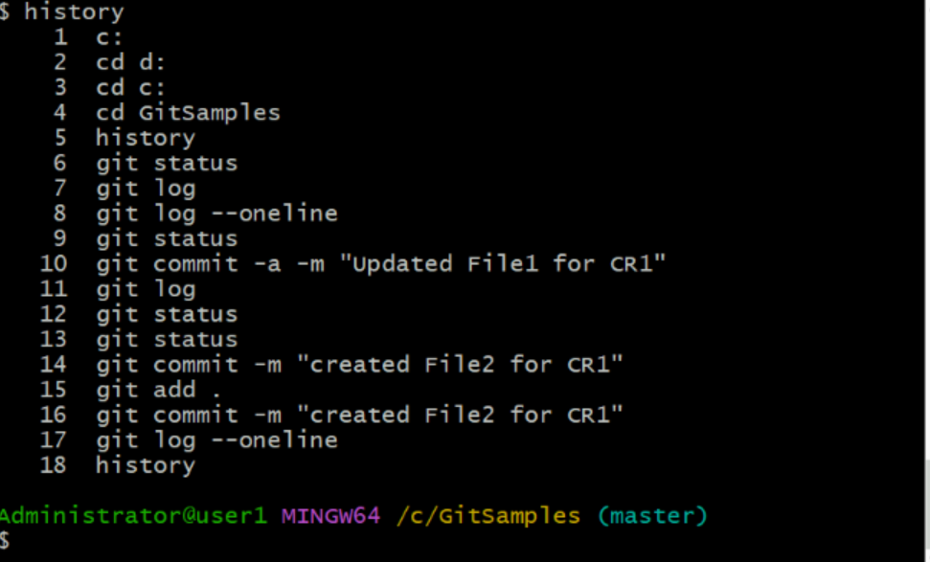

Git diff Modify the existing file and show git diff is to show unstaged changes

1. Edit index.html
2. git status
3. git diff index.html
4. it Explain minus and plus in the file list
5. Git add index.html

Git diff –staged is to show staged changed so before commit view the staged changes

1. Git diff –staged index.html
2. Now before commit edit the file again to show staged and unstaged changes
3. Vim index.html
4. Git status – will show both staged and unstaged file – explain difference between both
5. Git commit –a –m

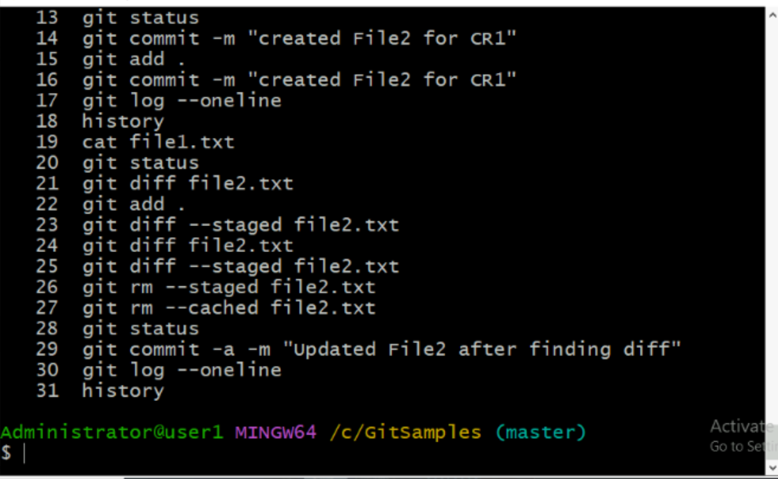

Git stash

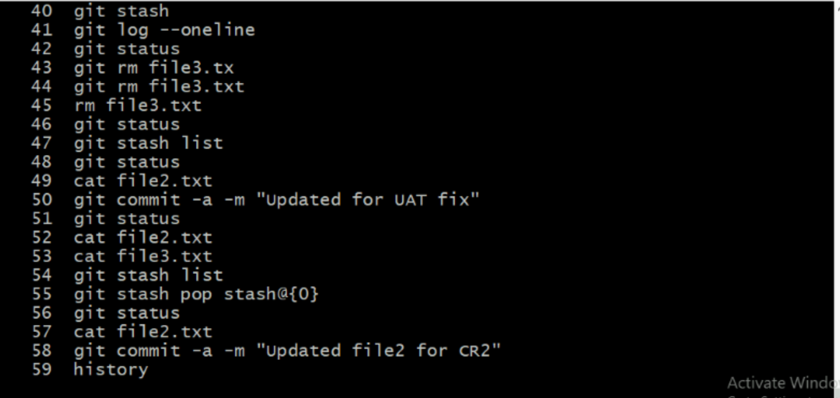



Branching & merging

